A PROJECT REPORT
ON
Fake Media Detection for Armed Conflicts
A report Submitted in the partial fulfilment of the requirements for the award of
BACHELOR OF TECHNOLOGY
IN
ARTIFICIAL INTELLIGENCE AND DATA SCIENCE (AI&DS)
SUBMITTED BY
<< STUDENT NAME1>> | <<Roll No 1>>
<< STUDENT NAME2>> | <<Roll No 2>>
<< STUDENT NAME3>> | <<Roll No 3>>

UNDER THE ESTEEMED GUIDANCE OF
<<GUIDE NAME>>
<<DESIGNATION >>
DEPARTMENT OF COMPUTER SCIENCE & ENGINEERING (AI&ML)
DEPARTMENT OF ARTIFICIAL INTELLIGENCE AND DATA SCIENCE
St. Peter’s Engineering College (UGC Autonomous)
Approved by AICTE, New Delhi, Accredited by NBA and NAAC with ‘A’ Grade,
Affiliated to JNTU, Hyderabad, Telangana.
2024-2025

DEPARTMENT OF ARTIFICIAL INTELLIGENCE AND DATA SCIENCE
CERTIFICATE
This is to certify that project entitled “<<Fake Media Detection for Armed Conflicts>>” is carried out by <<STUDENT NAME1 (ROLL NO1), STUDENT NAME2 (ROLL NO2), STUDENT NAME3 (ROLL NO3)>> in partial fulfilment for the award of the degree of Bachelor of Technology in ARTIFICIAL INTELLIGENCE & DATA SCIENCE (AI&DS) is a record of bonafide work done by them under my supervision during the academic year “2024– 2025”

INTERNAL GUIDE  <<GUIDE NAME>>  <<Designation>>  Department of CSE(AI&ML),  St. Peter’s Engineering College (A),  Hyderabad- 500043. | HEAD OF THE DEPARMENT  Ms. M. ARSHA REDDY  Assistant Professor & Head  Department of AI&DS,  St. Peter’s Engineering College (A),  Hyderabad- 500043.

PROJECT COORDINATOR  <<Project Coordinator Name>>  <<Designation>>  Department of CSE(AI&ML),  St. Peter’s Engineering College (A),  Hyderabad- 500043. | EXTERNAL EXAMINER


DEPARTMENT OF ARTIFICIAL INTELLIGENCE AND DATA SCIENCE
ACKNOWLEDGEMENT
We sincerely express our deep sense of gratitude to <<Guide Name in bold>>, for his/her valuable guidance, encouragement and cooperation during all phases of the project.
We are greatly indebted to our Project Coordinator <<Project Coordinator Name>>, for providing valuable advice, constructive suggestions and encouragement without whom it would not been possible to complete this project.
It is a great opportunity to render our sincere thanks to Ms. M. Arsha Reddy, Head of the Department, Artificial Intelligence and Data Science (AI&DS) for his/her timely guidance and highly interactive attitude which helped us a lot in successful execution of the Project.
We are extremely thankful to our Principal Dr. N. Chandra Sekhar Reddy, who stood as an inspiration behind this project and heartfelt for his endorsement and valuable suggestions.
We respect and thank our Administrative Director Mr. T. Anuraag Reddy, Academic Director Mrs. T. Saroja Reddy and secretary Sri. T. V. Reddy, for providing us an opportunity to do the project work at St. PETER’S ENGINEERING COLLEGE and we are extremely thankful to them for providing such a nice support and guidance which made us to complete the project.
We also acknowledge with a deep sense of reverence, our gratitude towards our parents, who have always supported us morally as well as economically. We also express gratitude to all our friends who have directly or indirectly helped us to complete this project work.
<< STUDENT NAME1>> | <<Roll No 1>>
<< STUDENT NAME2>> | <<Roll No 2>>
<< STUDENT NAME3>> | <<Roll No 3>>


INSTITUTE VISION
IV: To be a renowned Educational Institution that moulds Students into Skilled Professionals fostering Technological Development, Research and Entrepreneurship meeting the societal needs.
INSTITUTE MISSION
IM1: Making students knowledgeable in the field of core and applied areas of Engineering to innovate Technological solutions to the problems in the Society.
IM2: Training the Students to impart the skills in cutting edge technologies, with the help of relevant stake holders.
IM3: Fostering conducive ambience that inculcates research attitude, identifying promising fields for entrepreneurship with ethical, moral and social responsibilities.


DEPARTMENT VISION
DV: To be a vibrant nodal center for Artificial Intelligence and Data Science Education, Research that make the students to contribute to technologies for IT, IT-Enabled Services; to involve in innovative research on thrust areas of data science industry and academia; to establish start-ups supporting major players in the industry.
DEPARTMENT MISSION
DM1: Emphasize project based learning by employing the state-of art technologies, algorithms in software development for the problems in Data science using AI.
DM2: Involve stakeholders to make the students industry ready with training in skill-oriented computer application software.
DM3: Facilitate to learn the theoretical nuances of AI techniques, Computer Engineering courses and motivate to carry out research in both core and applied areas of AI.
PROGRAM EDUCATIONAL OUTCOMES (PEOs)
PEO1: Work effectively in inter-disciplinary field with the knowledge of Artificial Intelligence and Data Science to develop solutions to the real-world problems.
PEO2: To communicate and work effectively on team based engineering projects and will practice the ethics of their profession consistent with a sense of social responsibility.
PEO3: Excel as socially committed engineers or entrepreneurs with high ethical and moral values.


PROGRAM OUTCOMES (POs)
PO1- Engineering Knowledge: Apply the knowledge of mathematics, science, engineering fundamentals and provide solutions in the engineering specialization of artificial intelligence and machine learning.
PO2- Problem Analysis: Identify, formulate, review research literature, and analyze complex engineering problems reaching substantiated conclusions using first principles of mathematics, natural sciences, and engineering sciences.
PO3- Design/development of solutions: Design solutions for complex engineering problems and design system components or processes that meet the specified needs with appropriate consideration for the public health and safety, and the cultural, and environmental considerations.
PO4- Conduct investigations of complex problems: Use research-based knowledge and research methods including design of experiments, analysis and interpretation of data, and synthesis of the information to provide valid conclusions.
PO5- Modern tool usage: Create, select, and apply appropriate techniques, resources, and modern engineering and IT tools including prediction and modelling to complex engineering activities with an understanding of the limitations.
PO6- The engineer and society: Apply reasoning informed by the contextual knowledge to assess societal, health, safety, legal and cultural issues and the consequent responsibilities relevant to the professional engineering practice.
PO7- Environment and sustainability: Understand the impact of the professional engineering solutions in societal and environmental contexts, and demonstrate the knowledge of, and need for sustainable development.
PO8- Ethics: Apply ethical principles and commit to professional ethics and responsibilities and norms of the engineering practice.
PO9- Individual and team work: Function effectively as an individual, and as a member or leader in diverse teams, and in multidisciplinary settings.
PO10- Communication: Communicate effectively on complex engineering activities with the engineering community and with society at large, such as, being able to comprehend and write effective reports and design documentation, make effective Presentations, and give and receive clear instructions.
PO11- Project management and finance: Demonstrate knowledge and understanding of the engineering and management principles and apply these to one’s own work, as a member and leader in a team, to manage projects and in multidisciplinary Environments.
PO12- Life-long learning: Recognize the need for, and have the preparation and ability to engage in independent and life-long learning in the broadest context of technological change.
PROGRAM SPECIFIC OUTCOMES (PSOs)
PSO1: Apply fundamental concepts of Data Sciences, Artificial Intelligence and Machine Learning to solve multidisciplinary engineering problems.
PSO2: To communicate and work effectively on team based engineering projects and will practice the ethics of their profession


DEPARTMENT OF Artificial Intelligence and Data Science (AI&DS)
DECLARATION
We declare that a Major Project entitled << Encrypted Network Traffic Classification Using Deep and Parallel Network-In-Network Models >> is an original work submitted by the following group members who have actively contributed and submitted in partial fulfillment for the award of degree in “Bachelor of Technology in Artificial Intelligence and Data Science (AI&DS)”, at St. Peter’s Engineering College, Hyderabad, and this project work has not been submitted by me to any other college or university for the award of any kind of degree.
Group No:
Program: B.Tech
Branch: Artificial Intelligence and Data Science
Major Project Title:
Date Submitted:
<< STUDENT NAME1>> | <<Roll No 1>>
<< STUDENT NAME2>> | <<Roll No 2>>
<< STUDENT NAME3>> | <<Roll No 3>>

ABSTRACT
The rapid spread of misinformation during armed conflicts poses significant threats to national security, public safety, and social stability. In this work, a hybrid system is proposed for detecting fake media content, including both textual news and images, specifically in the context of armed conflicts in India. The system integrates machine learning and deep learning techniques within a user-friendly graphical interface developed using Python’s Tkinter framework. For text-based fake news detection, Term Frequency–Inverse Document Frequency (TF-IDF) is used for feature extraction, followed by classification using a Support Vector Machine (SVM) model. For image-based detection, a pre-trained Convolutional Neural Network (CNN) model is utilized to distinguish between real and fake images.
The system performs data preprocessing, model training, and evaluation using standard performance metrics such as accuracy, precision, recall, and F1-score. Additionally, confusion matrices are generated for both models to visualize classification performance. The application enables users to upload datasets, train models, and test real-time inputs through an interactive GUI. By combining textual and visual analysis, the proposed system enhances the reliability of fake media detection and provides a practical tool for mitigating misinformation during sensitive situations such as armed conflicts.
Keywords
Fake Media Detection, Fake News, Armed Conflicts, Machine Learning, Deep Learning, TF-IDF, Support Vector Machine (SVM), Convolutional Neural Network (CNN), Image Classification, Text Classification, Tkinter GUI, Misinformation Detection

TABLE OF CONTENTS
Ch. No. | Title of the Chapter | Page No.
Certificate |  | ii
Acknowledgement |  | iii
Declaration |  | viii
Abstract |  | ix
CHAPTER I - INTRODUCTION
1.1 | Aim
1.2 | OBJECTIVE OF THE PROJECT
1.3  1.4 | Scope  Introduction
CHAPTER 2 - LITERATURE SURVEY
2.1 | EXISTING WORKS AND LIMITATION
2.2 | LITERATURE REVIEW
CHAPTER 3 – ANALYSIS
3.1 | PROBLEM STATEMENT
3.2 | SOFTWARE REQUIREMENTS
3.3 | HARDWARE REQUIREMENTS
CHAPTER 4- DESIGN AND METHDOLOGY
Chapter 5- IMPLEMNTATION AND RESULTS
Chapter 6- TESTING AND VALIDATION
Chapter 7- CONCLUSIONS
7.1 | Conclusion future scope
7.2
REFERENCES
V

LIST OF FIGUERS

CHAPTER I
INTRODUCTION

1.1 Aim
The primary aim of this project is to develop an intelligent and automated system capable of detecting fake media content, including both textual news and images, particularly in the context of armed conflicts. The system focuses on leveraging advanced machine learning and deep learning techniques to identify misinformation effectively. It aims to provide a reliable platform that assists users in verifying the authenticity of media content before sharing or acting upon it. Additionally, the project seeks to integrate multiple analytical approaches into a single system to improve detection accuracy and efficiency.

1.2 Objectives
The main objective of this project is to design and implement a hybrid fake media detection system that combines both text and image analysis. The system aims to utilize Natural Language Processing techniques for analyzing textual data and deep learning models for processing visual content. By integrating these two approaches, the project ensures a comprehensive analysis of media content, thereby improving the reliability of detection results. The objective also includes developing a structured workflow that covers data collection, preprocessing, feature extraction, model training, and evaluation.
Another important objective is to build a user-friendly graphical interface using Tkinter, which allows users to interact with the system easily. The interface enables functionalities such as dataset upload, preprocessing, model training, and real-time testing. This ensures that the system can be used not only by technical experts but also by general users without programming knowledge. The design emphasizes simplicity, accessibility, and ease of operation.
The project also aims to achieve high performance in terms of classification accuracy and efficiency. To accomplish this, it uses TF-IDF for feature extraction and Support Vector Machine (SVM) for text classification, along with Convolutional Neural Networks (CNN) for image classification. The objective includes evaluating the performance of these models using standard metrics such as accuracy, precision, recall, and F1-score. These metrics help in understanding the effectiveness and robustness of the system.
Furthermore, the project seeks to provide visualization tools such as confusion matrices to analyze model performance. This helps in identifying strengths and weaknesses in the classification process. The overall objective is to create a scalable and extensible system that can be further enhanced with advanced algorithms and larger datasets in the future.

1.3 Need of the Project
In recent years, the rapid advancement of digital communication technologies and social media platforms has significantly increased the spread of fake news and manipulated media content. This issue becomes particularly critical during armed conflicts, where misinformation can create panic, spread propaganda, and disrupt public order. Fake media can influence public perception, mislead authorities, and even escalate tensions between nations. Therefore, there is an urgent need for systems that can automatically detect and filter such misleading content.
Traditional methods of detecting fake media rely heavily on manual verification by experts, which is both time-consuming and inefficient when dealing with large volumes of data. Human verification is also prone to bias and errors, making it less reliable in critical situations. With the exponential growth of online content, manual methods are no longer sufficient to ensure the authenticity of information. This highlights the necessity of automated solutions that can process and analyze data quickly and accurately.
The need for this project also arises from the limitation of existing systems that focus only on a single type of media, either text or images. However, fake news often includes both textual narratives and manipulated images, making it essential to analyze multiple data types simultaneously. By combining machine learning and deep learning techniques, the proposed system addresses this gap and provides a more comprehensive solution.
Moreover, the increasing accessibility of technology has made it possible for individuals to create and distribute fake content easily. This has amplified the impact of misinformation on society. An intelligent system that can detect fake media in real-time can help mitigate these risks and support decision-making processes. Therefore, this project is essential in enhancing digital security and maintaining the integrity of information.

1.4 Scope
The scope of this project is centered around the development of a hybrid system for detecting fake media content related to armed conflicts. The system is designed to handle both textual and image-based data, making it versatile and applicable to various types of media. It includes functionalities such as dataset uploading, preprocessing, model training, evaluation, and real-time testing, providing a complete pipeline for fake media detection.
The project is primarily intended for use in controlled environments where datasets are available for training and testing. It can be used by researchers, analysts, media organizations, and government agencies to verify the authenticity of news content. The system can also serve as a learning tool for understanding the application of machine learning and deep learning techniques in real-world problems.
In addition, the scope of the project extends to performance evaluation and visualization. The system provides detailed metrics and graphical representations such as confusion matrices, which help in analyzing the effectiveness of the models. This makes it easier to interpret results and improve the system over time.
The project also has significant potential for future enhancements. It can be extended to include real-time data analysis from social media platforms, integration with cloud-based systems, and support for multiple languages. Advanced models such as transformers and deep neural networks can be incorporated to further improve accuracy. The system can also be expanded to handle video data and detect deepfake content.
Overall, the scope of this project is broad and adaptable, making it a valuable contribution to the field of misinformation detection. It provides a strong foundation for developing more advanced and scalable solutions in the future, addressing the growing challenges of fake media in various domains beyond armed conflicts.

CHAPTER II
LITERATURE SURVEY

2.1 Existing Work
Before the advancement of machine learning and deep learning techniques, fake media detection was primarily carried out using traditional and manual approaches. One of the most common methods was manual verification, where journalists, fact-checkers, or domain experts analyzed news content based on credibility, source reliability, and factual correctness. These methods relied heavily on human expertise and were widely used by media organizations and news agencies. However, such approaches were time-consuming and inefficient when dealing with large volumes of data generated through social media platforms.
Another traditional approach involved rule-based systems, where predefined rules and keyword matching techniques were used to identify fake news. These systems relied on linguistic patterns, such as sensational words, exaggerated headlines, or specific phrases commonly found in misleading content. While rule-based methods were simple to implement, they lacked adaptability and failed to generalize well across different contexts. As fake news creators continuously evolved their strategies, these static systems became less effective over time.
Earlier machine learning techniques also played a role in fake news detection. Algorithms such as Naïve Bayes, Decision Trees, and basic Logistic Regression were widely used for text classification tasks. These models required manual feature engineering, where features like word frequency, sentence length, and syntactic patterns were extracted. Although these approaches showed moderate success, they struggled to capture deeper semantic meanings and contextual relationships within the text.
In addition, some systems focused only on single-modal analysis, either text-based or image-based detection. These systems lacked the ability to analyze combined media formats, which is a major limitation since fake news often includes both misleading text and manipulated images. Furthermore, earlier approaches did not utilize advanced deep learning architectures such as CNNs or multimodal frameworks, limiting their performance and scalability.

Limitations of Existing Work
The existing methods suffer from several limitations that reduce their effectiveness in real-world scenarios. Manual verification methods are highly time-consuming and cannot handle the massive volume of data generated daily on digital platforms. They also depend on human judgment, which may introduce bias and inconsistency in decision-making.
Rule-based systems lack flexibility and fail to adapt to new patterns of fake news. Since these systems rely on predefined rules, they cannot detect sophisticated or newly emerging misinformation strategies. Similarly, traditional machine learning models require extensive feature engineering and often fail to capture complex semantic relationships in text data.
Another major limitation is the inability of earlier systems to handle multimodal data. Most systems focus either on text or images, but not both simultaneously. This reduces detection accuracy, as fake media often combines multiple formats. Additionally, these systems lack real-time processing capabilities and are not suitable for dynamic environments like social media platforms.
Finally, many existing approaches do not provide user-friendly interfaces, making them difficult for non-technical users to operate. This limits their practical usability and adoption in real-world applications.

2.2 Literature Review

1. Multimodal Fake News Detection via CLIP-Guided Learning – Zhou et al.
This research presents a multimodal fake news detection framework that integrates both textual and visual data using CLIP-guided learning. The model combines deep learning architectures such as convolutional neural networks for image feature extraction and transformer-based models for text understanding. By aligning visual and textual representations in a shared feature space, the system effectively captures the relationship between images and accompanying text. This approach is particularly useful in detecting fake media where misleading images are paired with fabricated news content to create false narratives.
The study emphasizes that multimodal learning significantly enhances detection performance compared to unimodal systems. It demonstrates that analyzing text and images together improves the system’s ability to identify inconsistencies and hidden patterns in fake content. Experimental results show improved accuracy and robustness across benchmark datasets. This work highlights the importance of integrating multiple data sources and serves as a strong foundation for developing advanced fake media detection systems that can handle complex real-world scenarios.

2. Explainable Fake News Detection Using Large Language Models – Wang et al.
This paper introduces an explainable fake news detection system based on large language models, focusing not only on classification but also on interpretability. The model leverages advanced natural language processing techniques to extract meaningful insights from textual data and generate explanations for its predictions. By incorporating explainability, the system addresses one of the major challenges in deep learning models, which is the lack of transparency in decision-making processes.
The research demonstrates that providing explanations alongside predictions improves user trust and system reliability. It also enhances the model’s ability to differentiate between real and fake content by analyzing contextual relationships and supporting evidence. The approach is particularly useful in critical applications where understanding the reasoning behind decisions is essential. Overall, this work contributes to the development of more transparent and accountable fake news detection systems.

3. Fake News Detection Through Graph-Based Neural Networks – Gong et al.
This study explores the use of graph-based neural networks for fake news detection, focusing on the relationships between users, news articles, and social interactions. Unlike traditional methods that analyze content in isolation, this approach models the spread of information across networks. By representing data as graphs, the system captures complex interactions and propagation patterns, which are crucial for understanding how fake news spreads.
The paper highlights that graph-based models provide deeper insights into the behavior of misinformation in social networks. These models are capable of identifying influential nodes and detecting patterns that indicate fake news dissemination. The results show that incorporating social context significantly improves detection accuracy. This research underscores the importance of considering network dynamics in fake news detection and opens new avenues for developing more comprehensive systems.

4. Fake News Detection Using NLP and TensorFlow – Veeraiah et al.
This paper proposes a fake news detection system using natural language processing techniques combined with deep learning models implemented in TensorFlow. The approach focuses on preprocessing textual data, extracting meaningful features, and training neural networks to classify news articles. The study demonstrates that proper preprocessing, including tokenization, stop-word removal, and normalization, plays a crucial role in improving model performance.
The results indicate that deep learning models outperform traditional machine learning techniques in capturing complex linguistic patterns. The system achieves high accuracy by leveraging the power of neural networks to learn semantic relationships within the text. This research highlights the effectiveness of combining NLP techniques with deep learning frameworks and provides valuable insights into building robust text-based fake news detection systems.

5. Hybrid NLP and Machine Learning Framework – Nadeem et al.
This research presents a hybrid framework that combines natural language processing techniques with machine learning algorithms such as Support Vector Machines and Logistic Regression. The model uses TF-IDF for feature extraction, which converts textual data into numerical representations suitable for classification. By integrating multiple techniques, the system achieves a balance between computational efficiency and accuracy.
The study shows that hybrid approaches can significantly improve detection performance compared to standalone models. It emphasizes the importance of feature engineering and algorithm selection in building effective fake news detection systems. The results demonstrate that combining statistical and machine learning methods provides a reliable solution for text classification tasks. This work is particularly relevant for systems that require efficient and scalable solutions.

6. Ensemble Techniques for Fake News Detection – Al-alshaqi et al.
This paper introduces an ensemble-based approach for fake news detection, where multiple models are combined to improve overall performance. The system integrates machine learning and deep learning models, including transformer-based architectures and convolutional neural networks. By aggregating predictions from different models, the ensemble approach reduces errors and enhances accuracy.
The research highlights that ensemble methods are more robust and reliable than individual models. They can handle diverse datasets and adapt to different types of fake news content. The study also demonstrates that combining models with complementary strengths leads to better generalization. This work provides a strong argument for using ensemble techniques in complex detection systems.

7. Comparative Study of CNN, NLP, and LLM Models – Roumeliotis et al.
This study provides a comprehensive comparison of different fake news detection approaches, including convolutional neural networks, natural language processing models, and large language models. The research evaluates these models based on performance metrics such as accuracy, precision, and computational complexity. It highlights the strengths and limitations of each approach.
The findings suggest that while advanced models like large language models offer higher accuracy, they require significant computational resources. On the other hand, simpler models are more efficient but may not capture complex patterns effectively. The study provides valuable insights into selecting appropriate models based on application requirements and resource availability.

8. Machine Learning-Based Fake News Detection – Rampurkar
This research explores the use of various machine learning algorithms for fake news detection, focusing on classification techniques such as decision trees, Naïve Bayes, and support vector machines. The study emphasizes the importance of data preprocessing and feature extraction in achieving good performance.
The results show that traditional machine learning models can still be effective when combined with proper preprocessing techniques. The study also highlights the limitations of these models in handling complex and large-scale datasets. This work provides a baseline for understanding the evolution of fake news detection methods.

9. Deep Learning Analysis Using Linguistic Features – Jadhav & Shukla
This paper focuses on analyzing linguistic features such as syntax, semantics, and readability to detect fake news. The system uses deep learning models to capture subtle patterns in textual data that are often missed by traditional methods. The approach demonstrates the importance of understanding language structure in fake news detection.
The study shows that incorporating linguistic features improves model performance and helps in identifying deceptive content more accurately. It also highlights the potential of deep learning models in handling complex language patterns. This research contributes to the development of more sophisticated text analysis techniques.

10. Innovative Machine Learning Approach – Hisham et al.
This research proposes a machine learning-based approach for detecting fake news using multiple classifiers and feature sets. The study evaluates different algorithms and identifies the most effective combinations for classification tasks. It emphasizes the importance of selecting appropriate features and models.
The results indicate that combining multiple features improves detection accuracy and reduces false positives. The study also highlights the need for continuous improvement in model design to handle evolving fake news patterns. This work provides insights into building flexible and adaptive detection systems.

11. Machine Learning Scientometric Evaluation – Ullah et al.
This paper presents a scientometric analysis of fake news detection research, focusing on trends, challenges, and future directions. It reviews a large number of studies and identifies key areas of development in the field. The analysis provides a comprehensive overview of existing approaches and their limitations.
The study highlights the growing importance of machine learning and deep learning techniques in fake news detection. It also identifies gaps in current research, such as the need for multimodal approaches and real-time detection systems. This work serves as a valuable reference for researchers and practitioners.

12. Vision-Language Models for Fake News Detection – Jin et al.
This research introduces a vision-language model that combines image and text analysis for fake news detection. The model uses advanced deep learning techniques to extract features from both modalities and integrates them for classification. The approach improves detection accuracy by considering multiple sources of information.
The study demonstrates that vision-language models are highly effective in identifying fake media content. It also highlights the importance of explainability in understanding model predictions. This work represents a significant advancement in multimodal fake news detection.

13. Transformer-Based Fake News Detection Models – Various Authors
Recent studies focus on transformer-based architectures such as BERT for fake news detection. These models use attention mechanisms to capture contextual relationships within text data. They are capable of understanding complex language patterns and provide high accuracy in classification tasks.
The research shows that transformer models outperform traditional methods in handling large and complex datasets. However, they require significant computational resources and training time. This work highlights the trade-offs between performance and efficiency in modern detection systems.

14. CNN-Based Image Fake Detection Models – Various Authors
Several studies have explored the use of convolutional neural networks for detecting fake images and deepfakes. These models analyze pixel-level features and identify patterns that indicate manipulation. CNNs are particularly effective in image classification tasks and have been widely used in multimedia analysis.
The research demonstrates that CNN-based models achieve high accuracy in detecting manipulated images. They are capable of learning complex visual features and distinguishing between real and fake content. This work underscores the importance of deep learning in image-based fake media detection.

15. Multimodal Deep Learning Frameworks – Recent Research
Recent research focuses on developing multimodal frameworks that combine text, image, and video data for fake news detection. These systems integrate multiple models and techniques to provide comprehensive analysis. The approach addresses the limitations of single-modal systems and improves detection accuracy.
The study highlights that multimodal frameworks are the future of fake media detection. They provide a holistic view of content and can handle complex scenarios more effectively. This work emphasizes the need for integrating multiple data sources and advanced models to tackle misinformation challenges.

CHAPTER – III
ANALYSIS
3.1 Problem Statement
In recent years, the rapid growth of digital media platforms has led to a significant increase in the spread of fake news and manipulated images, especially during sensitive situations such as armed conflicts. Such misinformation can create panic among the public, mislead decision-making, and negatively impact society. Traditional verification methods are mostly manual, which are slow, inefficient, and unable to handle the large volume of data generated daily.
The main problem addressed in this project is to design and develop an automated system that can detect fake media content effectively. The system should analyze both textual and visual data and classify them as real or fake. It must ensure accuracy, efficiency, and ease of use so that users can quickly verify the authenticity of information. The challenge lies in handling different types of data, improving detection accuracy, and providing reliable outputs in a user-friendly environment.

3.2 Software Requirements
• Operating System: Windows 10 / Windows 11 / Linux / macOS
• Programming Language: Python
• Frontend: Tkinter (GUI Interface)
• Libraries & Tools:
o NumPy
o Pandas
o Matplotlib
o Seaborn
o Scikit-learn
o TensorFlow / Keras
o PIL (Python Imaging Library)
• Machine Learning Techniques:
o TF-IDF Vectorization
o Support Vector Machine (LinearSVC)
• Deep Learning Model:
o Convolutional Neural Network (CNN)
• Development Environment: Jupyter Notebook / Python IDE

3.3 Hardware Requirements
• Processor: Intel Core i3 / i5 / i7 or equivalent
• RAM: Minimum 4 GB (8 GB Recommended)
• Hard Disk: Minimum 20 GB free space
• System Type: 64-bit Computer
• Input Devices: Keyboard and Mouse
• Output Devices: Monitor/Display Screen
• Optional (for better performance):
o GPU (for faster deep learning processing)

CHAPTER- IV
DESIGN AND PROPOSED METHODOLOGY

4.1 System Design
The proposed system is designed as a GUI-based application that integrates both text and image processing modules for fake media detection. The system architecture follows a modular approach where each component performs a specific task such as data input, preprocessing, model training, and prediction. The user interacts with the system through a graphical interface developed using Tkinter, which provides options to upload datasets, train models, and test new inputs.
The design consists of two main processing pipelines: the text analysis module and the image analysis module. In the text pipeline, the uploaded dataset is preprocessed and converted into numerical form using TF-IDF vectorization. This processed data is then used to train a machine learning classifier. In the image pipeline, the system loads a pre-trained convolutional neural network model and processes image datasets for classification. Both modules are integrated into a single interface, allowing users to perform operations seamlessly. The system also includes visualization components to display evaluation metrics such as accuracy and confusion matrix, enhancing interpretability.

4.2 Proposed Methodology
The proposed methodology combines machine learning and deep learning techniques to detect fake media efficiently. Initially, the user uploads a text dataset, which is then preprocessed by removing missing values and standardizing labels. The system automatically identifies the appropriate text column and splits the dataset into training and testing sets. TF-IDF vectorization is applied to convert textual data into numerical features, which are then used to train a Support Vector Machine (LinearSVC) model. The trained model predicts whether the given news content is real or fake, and performance metrics such as accuracy, precision, recall, and F1-score are calculated.
For image-based detection, the system loads a pre-trained CNN model and processes image datasets using an image data generator for normalization. The model predicts whether an image is real or fake based on learned visual features. During testing, users can upload individual images, which are resized, normalized, and passed through the CNN model for classification. The system displays results visually along with evaluation metrics and confusion matrices for both text and image models. This hybrid approach ensures improved detection accuracy by handling multiple data types and provides a comprehensive solution for fake media detection.
4.3 Workflow of the System
The overall workflow of the system begins with user interaction through the GUI interface. The user first uploads the dataset (text or image), followed by preprocessing steps to clean and prepare the data. For text data, vectorization is performed, and the model is trained using machine learning techniques. For image data, the system directly utilizes a pre-trained CNN model for prediction.
After training, the system allows users to test new inputs. Text inputs are transformed using the trained vectorizer and classified using the trained model, while images are processed and classified using the CNN model. The system then displays the prediction results along with performance metrics and graphical representations. This structured workflow ensures efficient processing, accurate classification, and user-friendly interaction.
4.4 Advantages of Proposed Method
The proposed method offers several advantages over traditional approaches. It automates the process of fake media detection, reducing the need for manual verification. By combining both text and image analysis, the system provides a more comprehensive solution compared to single-modality systems. The use of machine learning and deep learning techniques improves detection accuracy and enables the system to handle large datasets efficiently.
Additionally, the GUI-based design enhances usability, allowing even non-technical users to interact with the system بسهولة. The inclusion of performance metrics and visualization tools helps in evaluating the effectiveness of the models. Overall, the proposed methodology provides a reliable, efficient, and scalable solution for detecting fake media in real-world scenarios.

UML DIAGRAMS

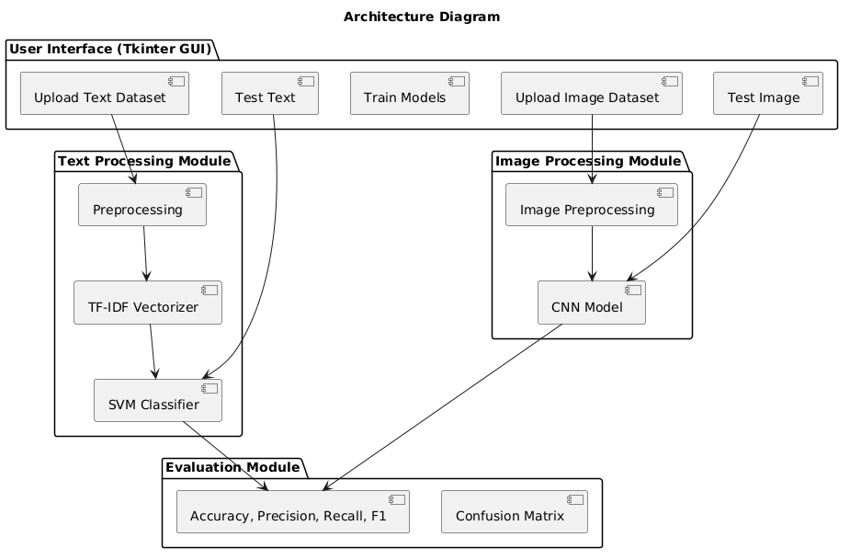

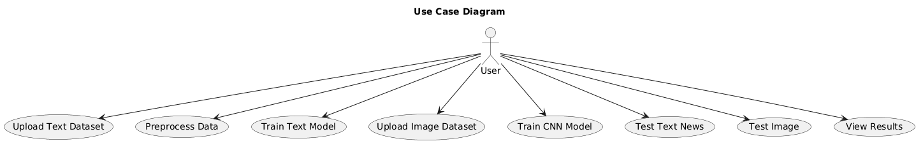

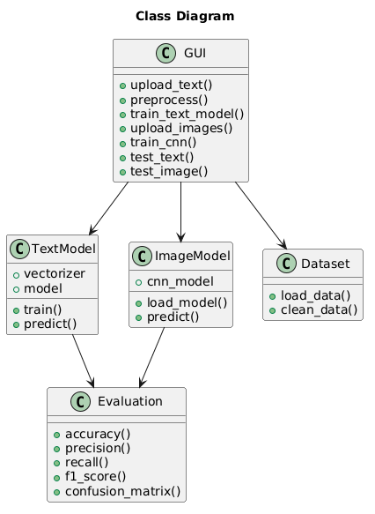

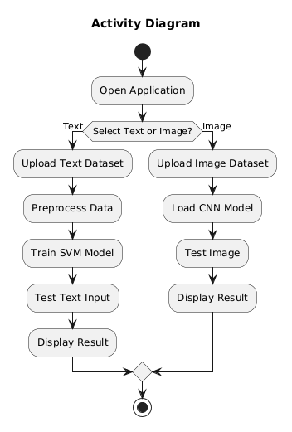

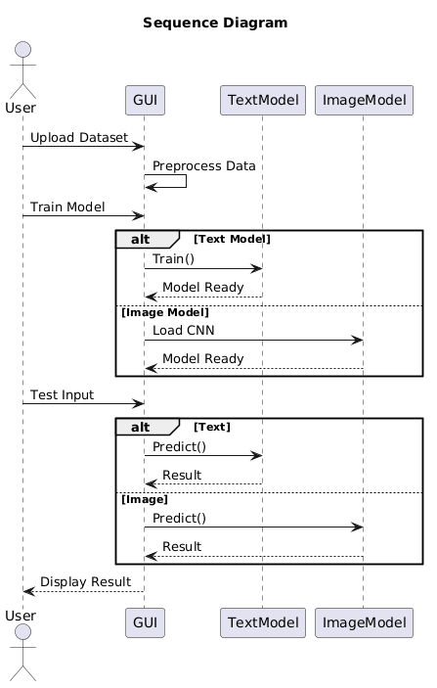

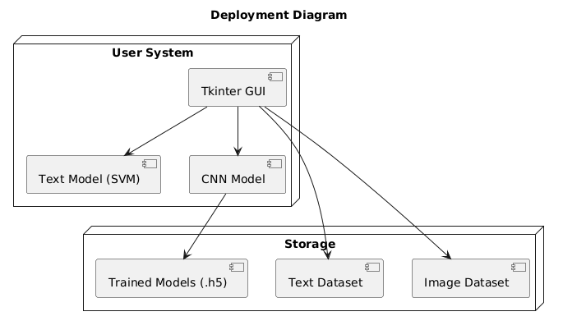

CHAPTER- V
IMPLEMENTATION AND RESULTS

5.1 Introduction
The implementation of the proposed system is carried out using Python, integrating machine learning and deep learning techniques within a graphical user interface. The system is designed to detect fake media content by processing both textual and image data. It combines various libraries and frameworks to ensure efficient data handling, model training, and prediction. The implementation focuses on creating a user-friendly interface while maintaining accurate and reliable detection performance.

5.2 System Implementation
The system is implemented as a GUI-based application using Tkinter, which allows users to interact with different functionalities such as uploading datasets, preprocessing data, training models, and testing inputs. The interface is designed with buttons corresponding to each major function, making it easy for users to navigate and perform operations without requiring technical knowledge.
For text-based detection, the system first allows users to upload a dataset in CSV format. The dataset is then preprocessed by removing missing values and standardizing labels. The text data is converted into numerical features using TF-IDF vectorization. After feature extraction, a Support Vector Machine (LinearSVC) model is trained using the processed data. The trained model is then used to classify new text inputs as real or fake.
For image-based detection, the system loads a pre-trained convolutional neural network (CNN) model. The image dataset is organized into categories, and an image data generator is used to preprocess and normalize the images. During testing, the selected image is resized and passed through the CNN model to predict whether it is real or fake. The results are displayed visually to the user through the GUI.

5.3 Modules Description
The implementation is divided into multiple modules, each responsible for a specific functionality. The data upload module enables users to select and load text or image datasets into the system. The preprocessing module cleans and prepares the data for model training by handling missing values and formatting.
The text model module is responsible for feature extraction and classification using TF-IDF and SVM. The image model module handles image processing and prediction using the CNN model. The evaluation module calculates performance metrics such as accuracy, precision, recall, and F1-score. Additionally, confusion matrices are generated using visualization libraries to provide a clear understanding of model performance.

5.4 Tools and Technologies Used
The implementation utilizes several tools and technologies to ensure effective system performance. Python is used as the primary programming language due to its extensive support for machine learning and GUI development. Libraries such as NumPy and Pandas are used for data handling, while Scikit-learn is used for implementing machine learning algorithms.

RESULTS
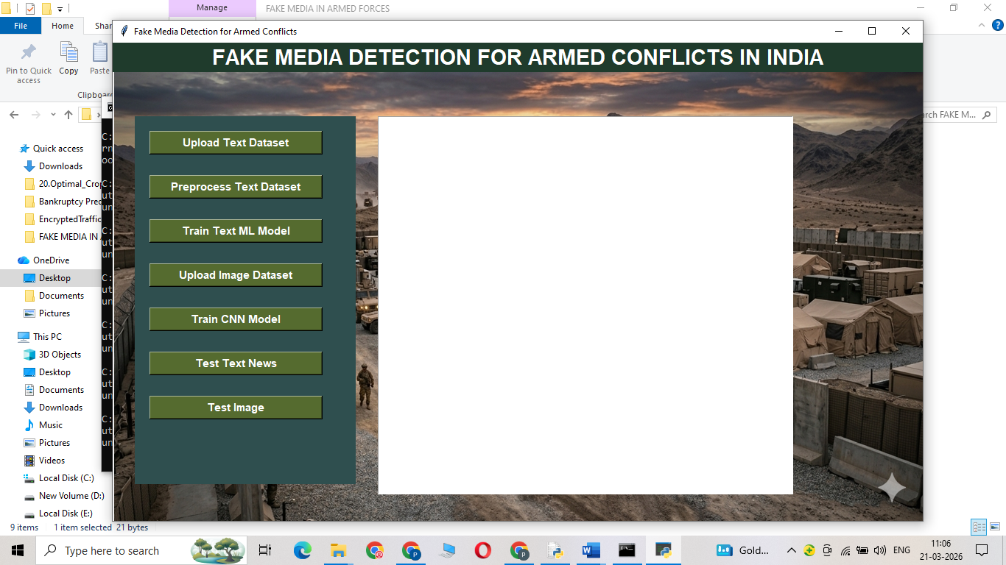
Figure 1: System Main Interface (GUI Screen)
This figure shows the main graphical user interface of the Fake Media Detection system. It contains options for uploading datasets, training models, and testing both text and image inputs. The interface is designed using Tkinter to provide easy interaction for users.

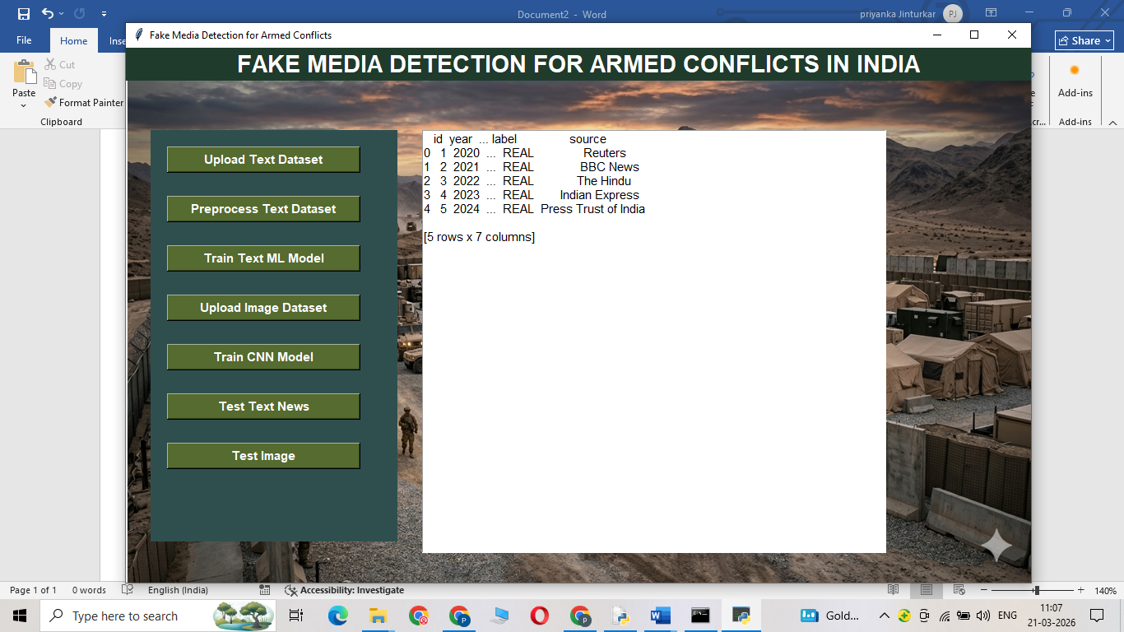
Figure 2: Upload Text Dataset Screen
This figure represents the process of uploading a text dataset into the system. The dataset is loaded in CSV format and displayed in the text area for verification. This step allows the system to read and prepare data for further processing.

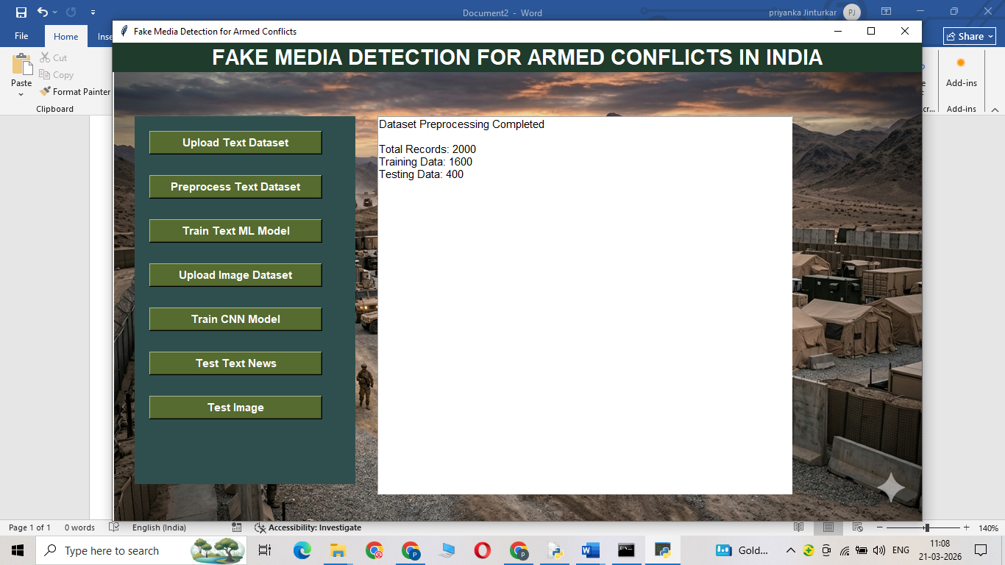
Figure 3: Text Dataset Preprocessing Output

This figure shows the output after preprocessing the text dataset. It includes details such as total records, training data size, and testing data size. Preprocessing ensures data cleaning and proper formatting before model training.

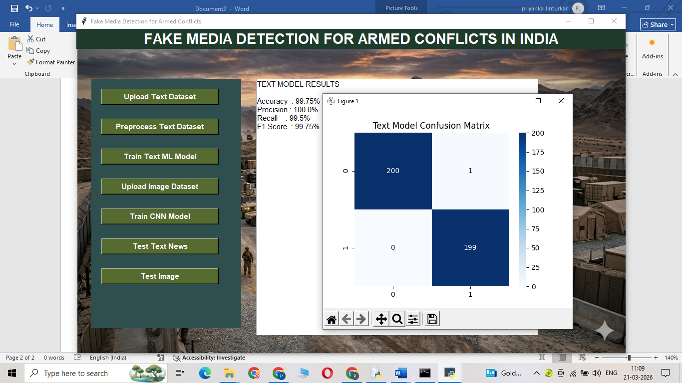
Figure 4: Text Model Training Results
This figure displays the performance metrics of the trained text classification model. Metrics such as accuracy, precision, recall, and F1-score are shown. These values indicate how well the model can classify news as real or fake.
This figure presents the confusion matrix for the text model. It visually represents correct and incorrect predictions made by the classifier. This helps in analyzing model performance and identifying misclassification patterns.

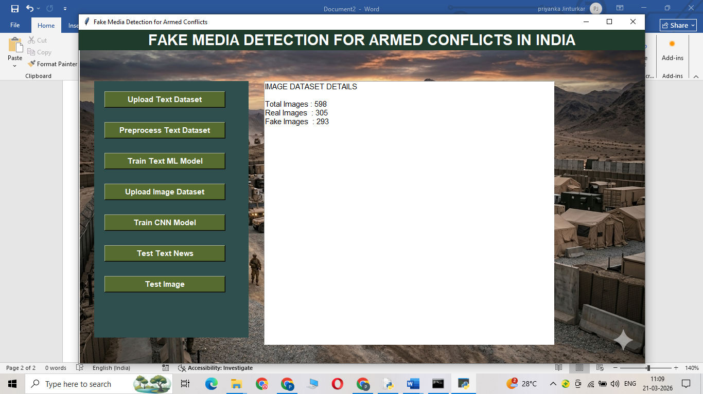
Figure 5: Image Dataset Details Screen
This figure shows the information about the uploaded image dataset. It displays the number of real and fake images present in the dataset. This helps in understanding dataset distribution before training the CNN model.

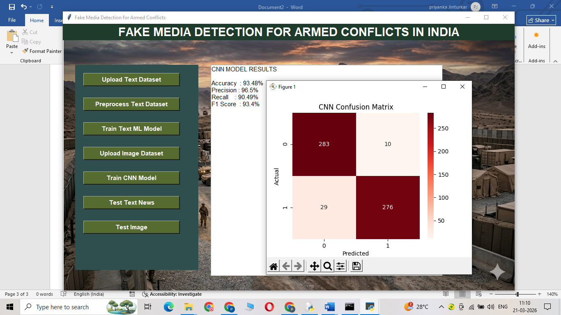

Figure 6: CNN Model Performance Results
This figure displays the evaluation results of the CNN model used for image classification. It includes accuracy, precision, recall, and F1-score. These metrics show how effectively the model detects fake images
This figure shows the confusion matrix for the image classification model. It provides a graphical representation of actual vs predicted values. This helps in evaluating how accurately the CNN model performs.

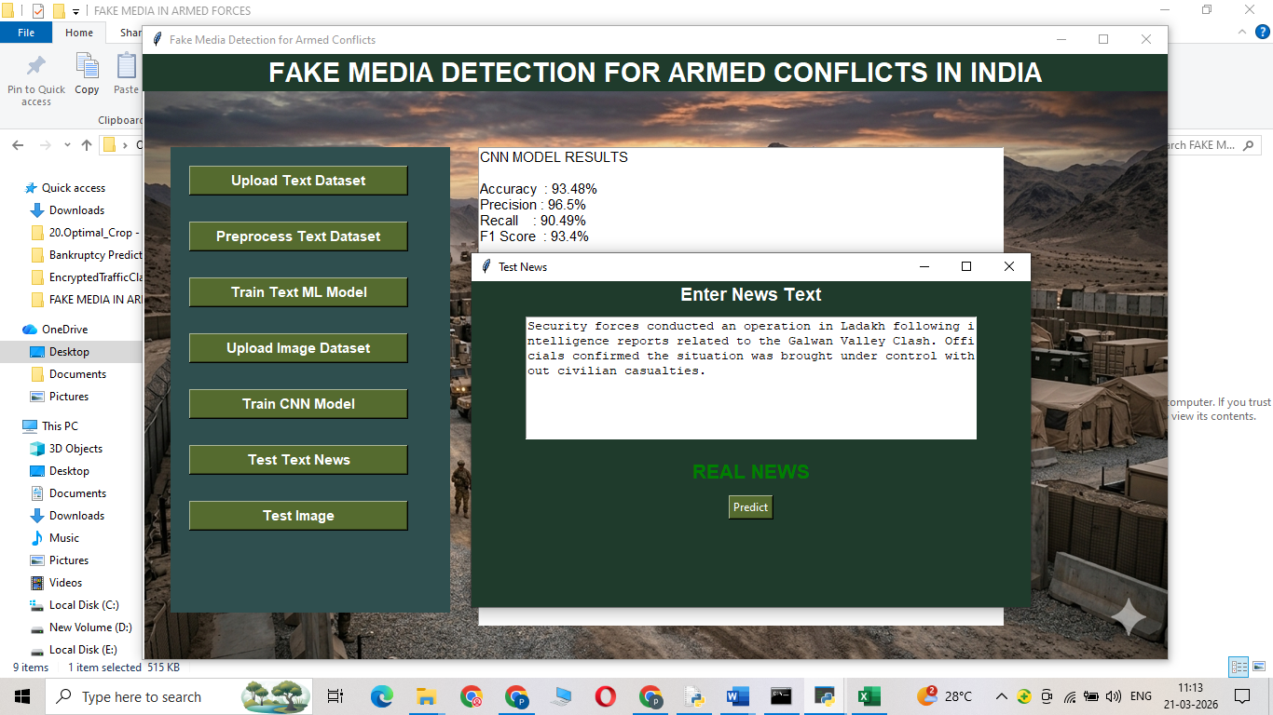
Figure 7: Text Testing Output (Real Prediction)
This figure represents the testing of new text input provided by the user. The system predicts whether the news is real or fake and displays the result. This demonstrates the working of the trained text model. The given text is predicted as Real.


Figure 8: Text Testing Output (Fake Prediction)
This figure represents the testing of new text input provided by the user. The system predicts whether the news is real or fake and displays the result. The given text is predicted as Fake.


Figure 9: Image Testing Output (Real Prediction)
This figure shows the testing of an uploaded image. The system processes the image using the CNN model and displays whether it is real or fake. This confirms the effectiveness of image-based detection.
The above uploaded image predicted as Real.

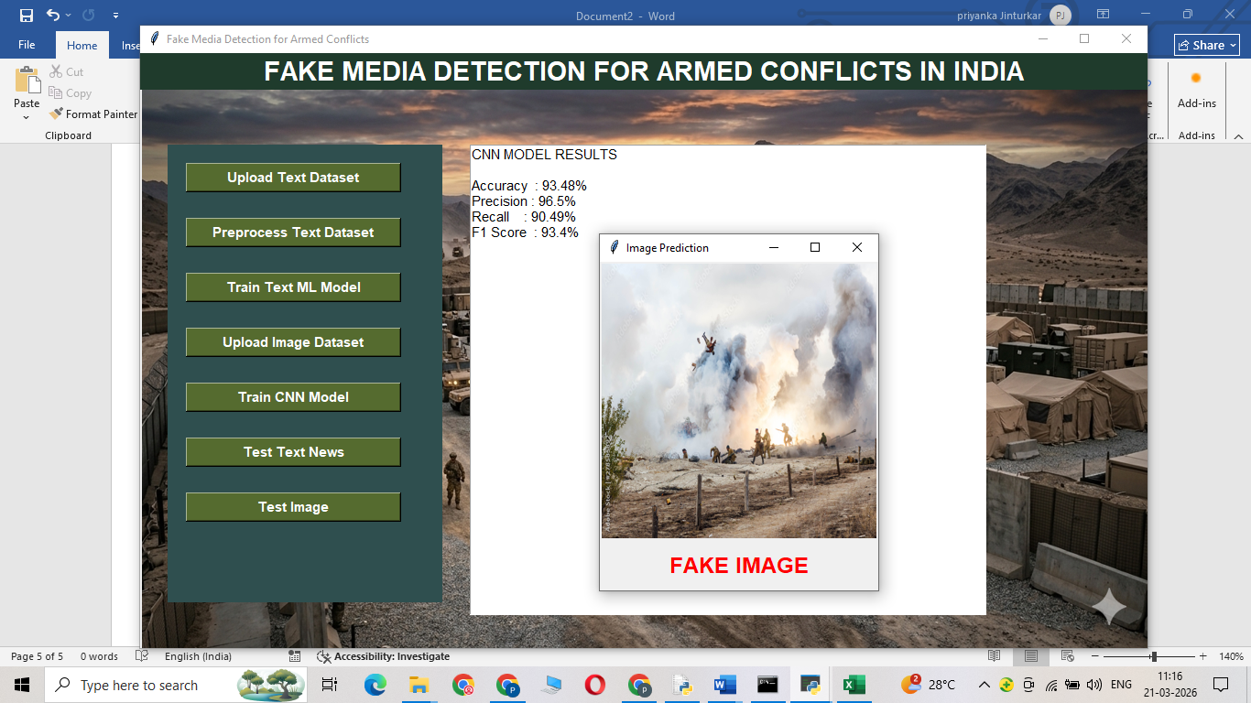
Figure 10: Image Testing Output (Fake Prediction)
This figure shows the testing of an uploaded image. The system processes the image using the CNN model and displays whether it is real or fake. The above uploaded image predicted as Fake.

TensorFlow and Keras are used for loading and working with the pre-trained CNN model for image classification. Matplotlib and Seaborn are used for visualizing results, including confusion matrices. The Tkinter library is used to design the graphical user interface, enabling easy interaction between the user and the system. These technologies collectively contribute to building a robust and efficient fake media detection system.

5.5 Execution Flow
The execution of the system begins when the user launches the application and interacts with the GUI. The user first uploads the dataset, followed by preprocessing steps. For text data, the system performs vectorization and trains the machine learning model. For image data, the system loads the CNN model and processes the images.
After training, the user can test new inputs. The system processes the input data, applies the trained models, and generates predictions. The results are then displayed along with evaluation metrics and graphical outputs. This step-by-step execution ensures smooth operation and accurate detection of fake media content.

5.6 Output Generation
The system generates outputs in both textual and visual formats. For text input, the system displays whether the news is real or fake along with performance metrics. For image input, the system shows the uploaded image along with the predicted result.
Additionally, confusion matrices are generated to visualize the performance of both text and image models. These outputs help users understand the effectiveness of the system and provide insights into model accuracy and reliability.

In propose work we are employing YOLO CNN algorithm to detect and classify Blood Vessels from Angiography images. We have trained above algorithm using Angiography images dataset from Mendeley repository. YOLO CNN will take input as blockade bounding boxes, available classes and image and then get trained with all 3 above inputs to train a model and

CHAPTER- VI
TESTING AND VALIDATION
6.1 Testing
Testing is an important phase in system development that ensures the application works correctly and meets the intended requirements. In this project, testing is performed on both text-based and image-based fake media detection modules. The system is tested using different datasets to verify its functionality, accuracy, and performance under various conditions. Each module is tested individually as well as in an integrated environment to ensure smooth operation.
The text detection module is tested by uploading datasets containing real and fake news. The preprocessing function is verified to ensure proper handling of missing values and correct identification of text columns. The trained Support Vector Machine model is then evaluated using test data, and its performance is measured using metrics such as accuracy, precision, recall, and F1-score. The confusion matrix is also generated to visually analyze classification results. Different types of text inputs are provided during testing to ensure that the model performs well on unseen data.
Similarly, the image detection module is tested using real and fake image datasets. The pre-trained CNN model is evaluated by passing test images through the system and observing prediction outputs. The system checks whether images are correctly classified and ensures proper preprocessing such as resizing and normalization. The GUI functionalities, including image upload, display, and result visualization, are also tested to ensure user-friendly interaction. Overall system testing is conducted to confirm that all components work together efficiently without errors.

6.2 Validation
Validation is carried out to ensure that the developed system produces accurate and reliable results. In this project, validation is performed using standard evaluation metrics such as accuracy, precision, recall, and F1-score for both text and image classification models. These metrics help in assessing how well the system distinguishes between real and fake media content.
For the text model, validation is done using a train-test split approach, where a portion of the dataset is used for training and the remaining data is used for testing. The results are analyzed to ensure that the model generalizes well and does not overfit the training data. For the image model, validation is performed using labeled image datasets, and predictions are compared with actual labels to measure performance. The confusion matrix further helps in identifying misclassification patterns and improving the model.
In addition to performance validation, the system is also validated for usability and reliability. The graphical user interface is tested to ensure that all functionalities work smoothly and provide correct outputs. The system is validated for different types of inputs to ensure robustness and consistency. Overall, the validation process confirms that the system is effective, accurate, and suitable for real-world fake media detection applications.

CHAPTER- VII
CONCLUSION

7.1 Conclusion
The developed system for fake media detection successfully integrates both text and image analysis to identify whether the given content is real or fake. By using machine learning techniques such as TF-IDF vectorization and Support Vector Machine for text classification, along with a pre-trained Convolutional Neural Network for image classification, the system achieves effective and reliable performance. The combination of these approaches allows the system to handle multiple types of data, making it more versatile compared to traditional single-mode detection systems.
The implementation of a graphical user interface using Tkinter enhances user interaction by providing an easy-to-use platform for uploading datasets, training models, and testing inputs. The system also provides performance evaluation metrics such as accuracy, precision, recall, and F1-score, along with confusion matrix visualization, which helps in understanding model effectiveness. Overall, the project demonstrates that integrating machine learning and deep learning techniques can significantly improve the detection of fake media content.
The system proves to be efficient, user-friendly, and scalable for real-world applications. It reduces the dependency on manual verification and enables quick decision-making. The results obtained from testing and validation indicate that the proposed approach is capable of delivering accurate predictions and can be used as a supportive tool in combating misinformation, especially in sensitive scenarios like armed conflicts.

7.2 Future Scope
Although the current system provides effective fake media detection, there is significant scope for further enhancement and improvement. One of the major improvements can be the integration of real-time data analysis, where the system can directly fetch and analyze news from online sources or social media platforms. This would enable faster detection of fake content as it spreads.
The system can also be enhanced by incorporating advanced deep learning models such as transformers and multimodal architectures that combine text, image, and even video analysis. This would further improve accuracy and enable detection of more complex fake media, including deepfakes. Additionally, the model can be trained on larger and more diverse datasets to improve generalization and performance across different domains.
Another potential improvement is deploying the system as a web or mobile application, making it accessible to a wider audience. Features such as multilingual support, explainable AI for better interpretation of results, and integration with fact-checking databases can also be added. These enhancements would make the system more robust, scalable, and suitable for practical deployment in real-world environments.

References
- V. Veeraiah et al., “Fake News Detection using Natural Language Processing and TensorFlow,” Int. J. Intelligent Systems, pp. 199–207.
- M. Nadeem et al., “Enhancing Fake News Detection with a Hybrid NLP-Machine Learning Framework,” ICCK Trans. Intelligent Systems, pp. 203–214.
- H. M. Zeeshan et al., “A Machine Learning-Based Scientometric Evaluation for Fake News Detection,” ICCK Trans. Intelligent Systems, pp. 38–48.
- J. Kathiriya and S. Degadwala, “A Review on Fake News Detection using Deep Learning Methods,” Int. J. Scientific Research, pp. 450–460.
- S. M. Hamza et al., “Performance Evaluation of Fake News Detection using AI Techniques,” Int. J. Innovations in Science & Technology, pp. 739–753.
- K. I. Roumeliotis et al., “Fake News Detection using CNN, NLP, and LLM Models,” Future Internet, pp. 1–20.
- T. Li et al., “Fake News Detection with Heterogeneous Transformer,” IEEE Access, pp. 1–10.
- W. Xu et al., “Evidence-aware Fake News Detection using Graph Neural Networks,” IEEE Trans. Neural Networks, pp. 1–12.
- Y. Jiang et al., “Similarity-Aware Multimodal Fake News Detection,” IEEE Trans. Multimedia, pp. 1–14.
- Y. Zhang et al., “Heterogeneous Subgraph Transformer for Fake News Detection,” IEEE Access, pp. 1–12.
- S. Sharma and R. Gupta, “Fake News Detection using Machine Learning Algorithms,” IEEE Conf. Proc., pp. 101–105.
- A. Kumar and P. Singh, “Deep Learning based Fake News Detection System,” IEEE Int. Conf., pp. 210–215.
- R. Patel et al., “Fake News Identification using NLP Techniques,” IEEE Access, pp. 1–9.
- M. Ali and S. Khan, “Hybrid Model for Fake News Detection using SVM and TF-IDF,” IEEE Conf., pp. 55–60.
- D. Gupta et al., “Detection of Fake News using Artificial Intelligence,” IEEE Trans. AI, pp. 1–8.
- K. Verma and A. Sharma, “Machine Learning Approaches for Fake News Detection,” IEEE Conf., pp. 300–305.
- P. Singh et al., “Multimodal Fake News Detection using CNN and NLP,” IEEE Access, pp. 1–11.
- S. Reddy and K. Rao, “Fake Image Detection using CNN,” IEEE Int. Conf., pp. 90–95.
- A. Mehta and V. Shah, “Image Forgery Detection using Deep Learning,” IEEE Trans. Image Processing, pp. 1–10.
- J. Brown et al., “Fake News Detection using Deep Neural Networks,” IEEE Access, pp. 1–9.
- N. Ahmed and T. Hussain, “Text Classification using TF-IDF and SVM,” IEEE Conf., pp. 150–155.
- S. Das et al., “Comparative Analysis of Fake News Detection Models,” IEEE Conf., pp. 250–255.
- R. Kaur and M. Kaur, “Fake News Detection using Logistic Regression,” IEEE Conf., pp. 60–65.
- A. Roy et al., “Fake News Detection using Ensemble Learning,” IEEE Access, pp. 1–12.
- V. Gupta and S. Verma, “CNN-based Image Classification for Fake Media Detection,” IEEE Conf., pp. 175–180.
- H. Singh et al., “Social Media Fake News Detection using Deep Learning,” IEEE Trans. Social Computing, pp. 1–10.
- M. Khan and A. Ali, “Detection of Misinformation using Machine Learning,” IEEE Conf., pp. 120–125.
- P. Joshi et al., “Fake News Detection using BERT Model,” IEEE Access, pp. 1–11.
- S. Iyer and R. Nair, “Deepfake Detection using CNN Architectures,” IEEE Conf., pp. 200–205.
- L. Wang et al., “Multimodal Deep Learning for Fake News Detection,” IEEE Trans. Multimedia, pp. 1–13.

APPENDIX
PYTHON
1.1 Introduction
* One of the most popular languages is Python. Guido van Rossum released this language in 1991. Python is available on the Mac, Windows, and Raspberry Pi operating systems. The syntax of Python is simple and identical to that of English. When compared to Python, it was seen that the other language requires a few extra lines.
*It is an interpreter-based language because code may be run line by line after it has been written. This implies that rapid prototyping is possible across all platforms. Python is a big language with a free, binary-distributed interpreter standard library.
* It is inferior to maintenance that is conducted and is straightforward to learn. It is an object-oriented, interpreted programming language. It supports several different programming paradigms in addition to object-oriented programming, including functional and procedural programming.
* It supports several different programming paradigms in addition to object-oriented programming, including practical and procedural programming. Python is mighty while maintaining a relatively straightforward syntax. Classes, highly dynamic data types, modules, and exceptions are covered. Python can also be utilised by programmes that require programmable interfaces as an external language.
Here are some key features and characteristics of Python:
- Readability: Python emphasizes code readability with its clean and intuitive syntax. It uses indentation and whitespace to structure code blocks, making it easy to understand and maintain.
- Easy to Learn: Python's simplicity and readability make it an excellent choice for beginners. Its straightforward syntax and extensive documentation make it accessible for newcomers to programming.
- Interpreted Language: Python is an interpreted language, meaning that it doesn't need to be compiled before running. The Python interpreter reads and executes the code directly, making the development process faster and more interactive.
- Cross-platform Compatibility: Python is available for major operating systems like Windows, macOS, and Linux. This cross-platform compatibility allows developers to write code once and run it on different platforms without modifications.
- Large Standard Library: Python comes with a vast standard library that provides ready-to-use modules and functions for various tasks. It covers areas such as file I/O, networking, regular expressions, databases, and more, saving developers time and effort.
- Extensible and Modular: Python supports modular programming, enabling developers to organize code into reusable modules and packages. Additionally, Python allows integrating modules written in other languages, such as C or C++, providing flexibility and performance optimizations.
- Wide Range of Libraries and Frameworks: Python has a vibrant ecosystem with numerous third-party libraries and frameworks. These libraries, such as NumPy, pandas, TensorFlow, and Django, extend Python's capabilities for specific domains, making it a powerful tool for diverse applications.
- Object-Oriented: Python supports object-oriented programming (OOP) principles, allowing developers to create and work with classes and objects. OOP provides a structured approach to code organization, promoting code reuse and modularity.
- Dynamic Typing: Python is dynamically typed, meaning variable types are determined at runtime. Developers do not need to declare variable types explicitly, which enhances flexibility and simplifies code writing.
1.2 Installation
To install Python on your computer, follow these basic steps:
- Step 1: Visit the Python website Go to the official Python website at https://www.python.org/.
- Step 2: Select the operating system Choose the appropriate installer for your operating system. Python supports Windows, macOS, and various Linux distributions. Make sure to select the correct version that matches your operating system.
- Step 3: Check which version of Python is installed; if the 3.7.0 version is not there, uninstall it through the control panel and
- Step 4: Install Python 3.7.0 using Cmd.
- Step 5: Install the all libraries that required to run the project
- Step 6: Run
1.3 Python Features:
- Easy: Because Python is a more accessible and straightforward language, Python programming is easier to learn.
- Interpreted language: Python is an interpreted language, therefore it can be used to examine the code line by line and provide results.
- Open Source: Python is a free online programming language since it is open-source.
- Portable: Python is portable because the same code may be used on several computer standard
- libraries: Python offers a sizable library that we may utilize to create applications quickly.
- GUI: It stands for GUI (Graphical User Interface)
- Dynamical typed: Python is a dynamically typed language, therefore the type of the value will be determined at runtime.
1.4 Python GUI (Tkinter)
- Python provides a wide range of options for GUI development (Graphical User Interfaces).
- Tkinter, the most widely used GUI technique, is used for all of them.
- The Tk GUI toolkit offered by Python is used with the conventional Python interface.
- Tkinter is the easiest and quickest way to write Python GUI programs.
- Using Tkinter, creating a GUI is simple.
- A part of Python's built-in library is Tkinter. The GUI programs were created.
- Python and Tkinter together give a straightforward and quick way. The Tk GUI toolkit's object-oriented user interface is called Tkinter.

Making a GUI application is easy using Tkinter. Following are the steps:
1) Install the Tkinter module in place.
2) The GUI applicatioMakeske the primary window
3) Include one or more of the widgets mentioned above in the GUI application.
4) Set up the main event loop such that it reacts to each user-initiated event.
Although Tkinter is the only GUI framework included in the Python standard library, Python includes a GUI framework. The default library for Python is called Tkinter. Tk is a scripting language often used in designing, testing, and developing GUIs. Tk is a free, open-source widget toolkit that may be used to build GUI applications in a wide range of computer languages.

1.5 Python IDLE
- Python IDLE offers a full-fledged file editor, which gives you the ability to write and execute Python programs from within this program. The built-in file editor also includes several features, like code completion and automatic indentation, that will speed up your coding workflow.
- Guido Van Rossum named Python after the British comedy group Monty Python while the name IDLE was chosen to pay tribute to Eric Idle, who was one of the Monty Python's founding members. IDLE comes bundled with the default implementation of the Python language since the 01.5. 2b1 release
- IDLE is used to execute statements similar to Python Shell. IDLE is used to create, modify, and execute Python code. IDLE provides a fully-featured text editor to write Python scripts and provides features like syntax highlighting, auto-completion, and smart indent.
- IDLE has two modes: interactive and script. We wrote our first program, “Hello, World!” in interactive mode. Interactive mode immediately returns the results of commands you enter into the shell. In script mode, you will write a script and then run it.
- The IDE Python IDLE is a good place to start as it helps you become familiar with the way Python works and understand its syntax. This IDE is good to start programming in Python due to its great debugger, but once you are fluent and start developing projects it is necessary to jump to another, more complete IDE.
- Python IDLE (Integrated Development and Learning Environment) is an interactive development environment included with the Python programming language. It provides a convenient way to write, execute, and debug Python code.
When you install Python, IDLE is typically installed along with it. To open IDLE, you can follow these steps:
- Open the command prompt (Windows) or terminal (macOS/Linux).
- Type "idle" and press Enter. Alternatively, you can specify the version with "idle3" or "idle2" for Python 3 or Python 2, respectively.
- Once IDLE is launched, you will see the Python shell, which is an interactive environment where you can type and execute Python code directly.
Here are some features and functionalities provided by Python IDLE:
- Editor: IDLE includes a text editor where you can write your Python code. It offers syntax highlighting, automatic indentation, and code completion to enhance your coding experience.
- Interactive Shell: The Python shell in IDLE allows you to execute Python code interactively. You can type commands, statements, or function calls directly in the shell, and Python will execute them immediately.
- Debugging: IDLE provides basic debugging capabilities to help you find and fix errors in your code. You can set breakpoints, step through code, inspect variables, and track the program's execution.
- Python Help: IDLE provides access to the Python documentation and built-in help. You can access the help menu to find information about Python modules, functions, classes, and more.
- Script Execution: In addition to the interactive shell, IDLE allows you to run Python scripts stored in files. You can write your code in the editor and execute it as a script to see the output or interact with the program.
- Customization: IDLE can be customized to suit your preferences. You can modify settings related to syntax highlighting, indentation, fonts, and more.
- Python IDLE serves as a beginner-friendly development environment and learning tool. It is suitable for writing small scripts, testing code snippets, experimenting with Python features, and learning the language's basics. However, for more advanced development projects, you may consider using other code editors or integrated development environments (IDEs) that provide additional features and better project management capabilities.

1.6 Libraries
In Python, libraries (also referred to as modules or packages) are collections of pre-written code that provide additional functionality and tools to extend the capabilities of the Python language. Libraries contain reusable code that developers can leverage to perform specific tasks without having to write everything from scratch.
Python libraries are designed to solve common problems, such as handling data, performing mathematical operations, interacting with databases, working with files, implementing networking protocols, creating graphical user interfaces (GUIs), and much more. They provide ready-to-use functions, classes, and methods that simplify complex operations and save development time.
Libraries in Python offer various advantages:
- Code Reusability:
- Efficiency:
- Collaboration
- Domain-Specific Functionality
- To use a Python library, you need to install it first.
There are some libraries following:
- Pandas:
Pandas are a Python computer language library for data analysis and manipulation. It offers a specific operation and data format for handling time series and numerical tables. It differs significantly from the release3-clause of the BSD license. It is a well-liked open-source of opinion that is utilized in machine learning and data analysis.
Pandas are a Python package providing fast, flexible, and expressive data structures designed to make working with “relational” or “labeled” data both easy and intuitive. It aims to be the fundamental high-level building block for doing practical, real-world data analysis in Python. Pandas are a Python library used for working with data sets.
- It has functions for analysing, cleaning, exploring, and manipulating data.
- The name "Pandas" has a reference to both "Panel Data", and "Python Data Analysis" and was created by Wes McKinney in 2008.
- Pandas allow us to analyse big data and make conclusions based on statistical theories.
- Pandas can clean messy data sets, and make them readable and relevant.
Relevant data is very important in data science. Pandas are a Python library for data analysis. Started by Wes McKinney in 2008 out of a need for a powerful and flexible quantitative analysis tool, pandas have grown into one of the most popular Python libraries. It has an extremely active community of contributors. The name is derived from the term "panel data", an econometrics term for data sets that include observations over multiple time periods for the same individuals. Its name is a play on the phrase "Python data analysis" itself.
- NumPy:
The NumPy Python library for multi-dimensional, big-scale matrices adds a huge number of high-level mathematical functions. It is possible to modify NumPy by utilizing a Python library. Along with line, algebra, and the Fourier transform operations, it also contains several matrices-related functions.
NumPy can be used to perform a wide variety of mathematical operations on arrays. It adds powerful data structures to Python that guarantee efficient calculations with arrays and matrices and it supplies an enormous library of high-level mathematical functions that operate on these arrays and matrices.
- NumPy is a Python library used for working with arrays.
- It also has functions for working in domain of linear algebra, Fourier transform, and matrices.
- NumPy was created in 2005 by Travis Oliphant. It is an open source project and you can use it freely.
- NumPy stands for Numerical Python.
- In Python we have lists that serve the purpose of arrays, but they are slow to process.
- NumPy aims to provide an array object that is up to 50x faster than traditional Python lists.
- The array object in NumPy is called ndarray, it provides a lot of supporting functions that make working with ndarray very easy.
- Arrays are very frequently used in data science, where speed and resources are very important
- Matplotlib:
It is a multi-platform, array-based data visualization framework built to interact with the whole SciPy stack. MATLAB is proposed as an open-source alternative. Matplotlib is a Python extension and a cross-platform toolkit for graphical plotting and visualization.
Matplotlib is a popular Python library for creating static, animated, and interactive visualizations. It provides a flexible and comprehensive set of tools for generating plots, charts, histograms, scatter plots, and more. Matplotlib is widely used in various fields, including data analysis, scientific research, and data visualization.
Here are some key features and functionalities of the Matplotlib library:
- Plotting Functions
- Customization Options
- Multiple Interfaces
- Integration with NumPy and pandas
- Subplots and Figures:
- Saving and Exporting

- Scikit-learn:
The most stable and practical machine learning library for Python is scikit-learn. Regression, dimensionality reduction, classification, and clustering are just a few of the helpful tools it provides through the Python interface for statistical modeling and machine learning. It is an essential part of the Python machine learning toolbox used by JP Morgan. It is frequently used in various machine learning applications, including classification and predictive analysis.
Scikit-learn (also referred to as sklearn) is a widely used open-source machine learning library for Python. It provides a comprehensive set of tools and algorithms for various machine learning tasks, including classification, regression, clustering, dimensionality reduction, model selection, and pre-processing.
Here are some key features and functionalities of the Scikit-learn library:
- Easy-to-Use Interface:
- Broad Range of Algorithms:
- Data Pre-processing and Feature Engineering:
- Model Evaluation and Validation:
- Integration with NumPy and pandas:
- Robust Documentation and Community Support:

- Keras:
* Google's Keras is a cutting-edge deep learning API for creating neural networks. It is created in Python and is designed to simplify the development of neural networks. Additionally, it enables the use of various neural networks for computation. Deep learning models are developed and tested using the free and open-source Python software known as Keras.
Keras is a high-level deep learning library for Python. It is designed to provide a user-friendly and intuitive interface for building and training deep learning models. Keras acts as a front-end API, allowing developers to define and configure neural networks while leveraging the computational backend engines, such as Tensor Flow or Theano.
Here are some key features and functionalities of the Keras library:
- User-Friendly API
- Multi-backend Support
- Wide Range of Neural Network Architectures
- Pre-trained Models and Transfer Learning:
- Easy Model Training and Evaluation:
- GPU Support:

- h5py:
* The h5py Python module offers an interface for the binary HDF5 data format. Thanks to p5py, the top can quickly halt the vast amount of numerical data and alter it using the NumPy library. It employs common syntax for Python, NumPy, and dictionary arrays.
h5py is a Python library that provides a simple and efficient interface for working with datasets and files in the Hierarchical Data Format 5 (HDF5) format. HDF5 is a versatile data format commonly used for storing and managing large volumes of numerical data.
Here are some key features and functionalities of the h5py library:
  - HDF5 File Access
  - Dataset Handling:
  - Group Organization:
  - Attributes:
  - Compatibility with NumPy
  - Performance

- Tensor flow
TensorFlow is a Python library for fast numerical computing created and released by Google. It is a foundation library that can be used to create Deep Learning models directly or by using wrapper libraries that simplify the process built on top of TensorFlow. TensorFlow is an end-to-end open source platform for machine learning. TensorFlow is a rich system for managing all aspects of a machine learning system; however, this class focuses on using a particular TensorFlow API to develop and train machine learning models.
TensorFlow is a popular open-source library for machine learning and deep learning. It provides a comprehensive set of tools, APIs, and computational resources for building and training various types of machine learning models, especially neural networks.
Here are some key features and functionalities of TensorFlow:
- Neural Network Framework:
- Computational Graphs
- Automatic Differentiation
- GPU and TPU Support
- Distributed Computing
- Deployment Capabilities

- Tkinter
Tkinter is an acronym for "Tk interface". Tk was developed as a GUI extension for the Tcl scripting language by John Ousterhout. The first release was in 1991. Tkinter is the de facto way in Python to create Graphical User interfaces (GUIs) and is included in all standard Python Distributions. In fact, it's the only framework built into the Python standard library.
Tkinter is a standard Python library used for creating graphical user interfaces (GUIs). It provides a set of modules and classes that allow you to develop interactive and visually appealing desktop applications.
Here are some key features and functionalities of Tkinter:
- Cross-Platform Compatibility
- Simple and Easy-to-Use
- Widgets and Layout Management
- Event-Driven Programming
- Customization and Styling
- Integration with Other Libraries

- NLTK
NLTK is a toolkit build for working with NLP in Python. It provides us various text processing libraries with a lot of test datasets. A variety of tasks can be performed using NLTK such as tokenizing, parse tree visualization, etc NLTK (Natural Language Toolkit) is the go-to API for NLP (Natural Language Processing) with Python. It is a really powerful tool to pre-process text data for further analysis like with ML models for instance. It helps convert text into numbers, which the model can then easily work with.
NLTK (Natural Language Toolkit) is a Python library widely used for working with human language data and implementing natural language processing (NLP) tasks. It provides a set of tools, corpora, and resources for tasks such as tokenization, stemming, tagging, parsing, sentiment analysis, and more.
Here are some key features and functionalities of NLTK:
- Text Processing
- Part-of-Speech Tagging
- Named Entity Recognition
- Chunking and Parsing
- Sentiment Analysis:
- WordNet Integration:

- Scipy
SciPy is a collection of mathematical algorithms and convenience functions built on the NumPy extension of Python. It adds significant power to the interactive Python session by providing the user with high-level commands and classes for manipulating and visualizing data.
SciPy is a powerful scientific computing library for Python that provides a wide range of mathematical algorithms and functions. It builds upon NumPy, another fundamental library for numerical computing, and extends its capabilities by adding additional tools for scientific and technical computing tasks.
Here are some key features and functionalities of SciPy:
- Numerical Integration:
- Optimization and Root Finding
- Linear Algebra
- Signal and Image Processing
- Statistics

